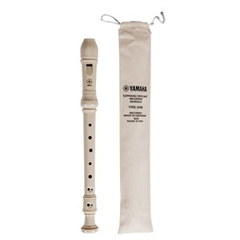

5th Grade Recorders!

5th grade students will be playing the recorder this year. The purpose of the recorder is to learn to read music and play notes on the staff. They will play recorders using the “Recorder Karate” program. Students can earn “belts” for learning assigned songs. Once the notes are learned, this will be a self-paced program for students who enjoy reading music and want to continue playing on their own. Students will be leaving the recorder in the music room so that they are always ready to play! They are welcome to take home their recorder to practice, however, it needs to stay in their backpack so it is ready for music class.
If you already have a recorder at home from an older sibling or from last year at Folsom, then that recorder is just fine. Please go ahead and send it to school, clearly labeled. I have some recorders in the classroom available for borrowing. They are very easy to clean with lukewarm water and mild soap.
If you would prefer to own your own recorder, then the best quality recorder is the one pictured above (cream colored), which is the Yamaha Soprano recorder YRS-24B. Other quality brands are Kingsley and Peripole. You can find these at the Music and Arts store in Frisco and Allen, or on amazon.com, or sweetpipes.com. Please do not use a recorder purchased from a grocery store or the dollar store.
Thank you,

Kristi Stephens
Music Teacher, Folsom Elementary
kkstephens@prosper-isd.net

